F8 : 3
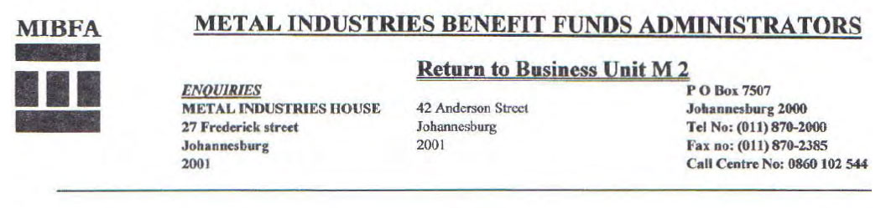

HOW TO COMPLETE THE EXCHANGE
CONTROL QUESTIONNARIE

Do not complete SECTION A, the fun will supply this information.

SECTION B has to be completed by you the applicant I beneficiary.

From questions 1-3 you have to select ONLY ONE of the three
questions and complete it fully

ALL the questions on the back of the form have to be completed.

If you can't remember, are not sure or don't know, you should indicate
it on the questionnaire i.e. not sure or don't know and not leave
answer space blank.

PLEASE NOTE THAT NO TIPPEX OR ALTERATIONS WILL BE
ACCEPTED ON THE EXCHANGE CONTROL QUESTIONNAIRE.

We trust the above is of assistance.

F8 : 2
1

INFORMATION REQUIRED BY THE EXCHANGE CONTROL AUTHORITIES:

As you are now resident outside the monetary area of the Republic of South Africa, and in order to satisfy Government Regulations, the following information is required before we can transfer funds to your order:

Section A
Pension / Provident full name :________________________________________
Pension / Provident Fund Number or Identity Number :________________________________________
Full names of beneficiary :________________________________________
Amount due to the beneficiary :________________________________________
Monthly / Quarterly / Half- year pension / Lump Sum :________________________________________
Amount Due to beneficiary in respect of arrear pension
Payments :________________________________________
Period during which the arrears have accrued :________________________________________

Section B – Declaration by beneficiary:
1. Full names (Mr/Mrs/Miss)(Initials are not acceptable) :________________________________________
2. Present Address :________________________________________
:________________________________________
3. State Country of which you are a permanent resident. :________________________________________
4. Date of your arrival in South Africa :________________________________________
5. The date of permanent departure from South Africa :________________________________________

PLEASE SELECT THE APPLICABLE OPTION:
- If you have emigrated from the Republic of South Africa, please state the following:
  - Date of emigration
  - Full name and address of the South African Bank:______________________________
that attended to your emigration :________________________________________
  - amount of foreign exchange received at
time of emigration (if Nil, please state) :________________________________________
  - list of remaining blocked South African
assets (if Nil, please state) :________________________________________
  - (for married women only) The full names
of your husband. (Initials are not acceptable):________________________________________

- If you are a South African Citizen who is temporarily resident outside of the Republic, please state the following:
  - Date of departure :________________________________________
  - Intended date of return :________________________________________
  - Reason for absence from the Republic :________________________________________
  - Amount of foreign exchange received at and / or since your departure
by yourself and / or your wife / husband :________________________________________
  - Name and address of bank that arranged the
Transfer of Funds :________________________________________

- If you were not born in South Africa i.e. if you immigrated to South Africa and have now returned abroad, please state the following:
  - The country from which you emigrated to South Africa:______________________________
  - Date of arrival in South Africa :________________________________________
  - If your immigration was placed on record, :________________________________________
please give the name and address of the :________________________________________
South African Bank which attended this :________________________________________
on your behalf :________________________________________
  - If you imported funds into South Africa at the
time of arrival, or thereafter, please state the
amount of foreign currency imported :________________________________________

2

The following questions must be answered by ALL applicants:
- From which country were the pension fund
Contributions paid? :________________________________________
- If the contributions have at any time since
Emigration been paid from funds in South Africa,
from what source was the money obtained? :________________________________________
- State (if possible)
  - Date of commencement of contributions
to the Pension / provident fund. :________________________________________
  - Where were you resident at the time? :________________________________________
- Currency of benefits? :________________________________________
- Your nationality : South African___________________________
- Why money is being remitted? :________________________________________
- What amount of foreign exchange did you avail
Of When leaving South Africa? :________________________________________
- Was a settling in / emigration allowance availed
on your departure? :________________________________________
- Bank and branch through which above transactions
Effected :________________________________________
- Account numbers with above bank :________________________________________
- Please furnish details of any other assets, if any,
held by you in South Africa. State the name of the
Institution or person who controls these assets
on your behalf :________________________________________
- Would you like your Funds to be invested in South
Africa? :________________________________________
- Is it your intention to return to South Africa? :________________________________________
- Were you a temporary or permanent resident of
South Africa? :________________________________________
- Were you employed on a contract basis, if so
Please Stipulate the period of employment
& residency :________________________________________

SIGNATURE:_________________________________ DATE:____________________________________

NB: Should you wish your funds to be transferred, then please provide us with details of your
Overseas BANKERS:

NAME: …………………………………………………………………………………..

ADDRESS: ………………………………………………………………………………

BANK ACCOUNT NUMBER: …………………………………………………………
This order will remain in place until cancelled by you.

SIGNATURE:_________________________________ DATE:____________________________________

IMPORTANT: Please attach a certified copy of your passport or certificate confirming citizenship of the country of residence.

If you are entitled to receive a Widow / er's Pension / Provident Benefit and your late husband / wife was the contributing member, we will require a certified copy of his / her death certificate in addition to the above documents

COPIES AND FAXED COPIES ARE NOT ACCEPTABLE.

